How to download tomcat in windows10:

Use below link

<https://tomcat.apache.org/download-90.cgi>

under **Binary Distributions**

under core

select Zip

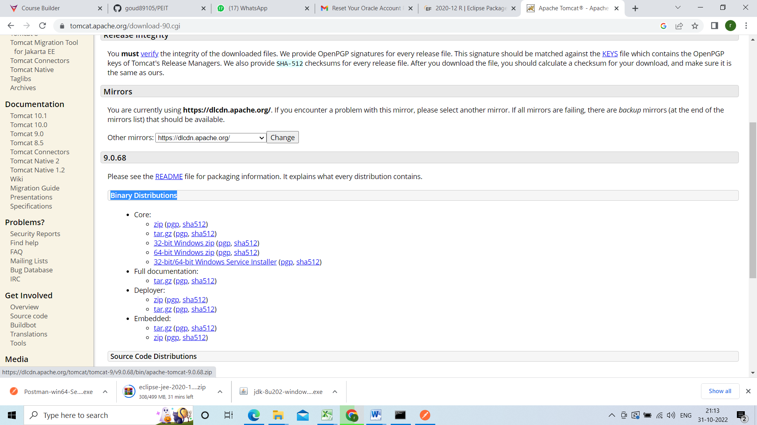

Then it will start the download after downloading go to downloads folder and copy and paste in u r local drive D or E and extract it

